VÉRNYOMÁS

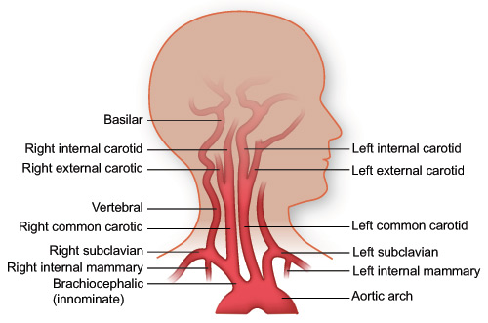
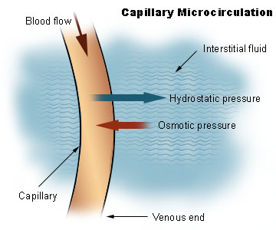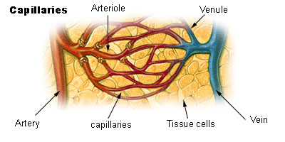
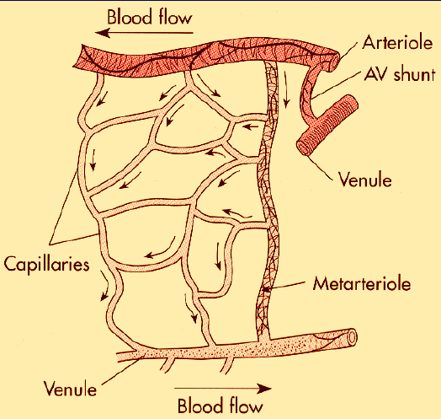




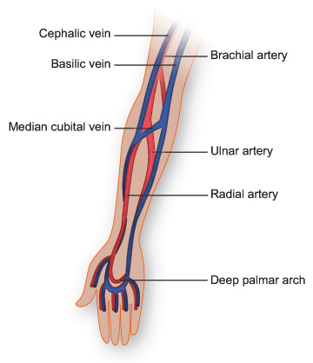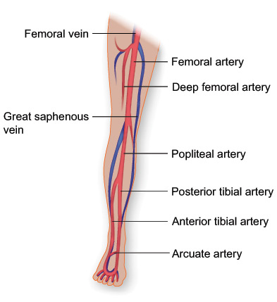
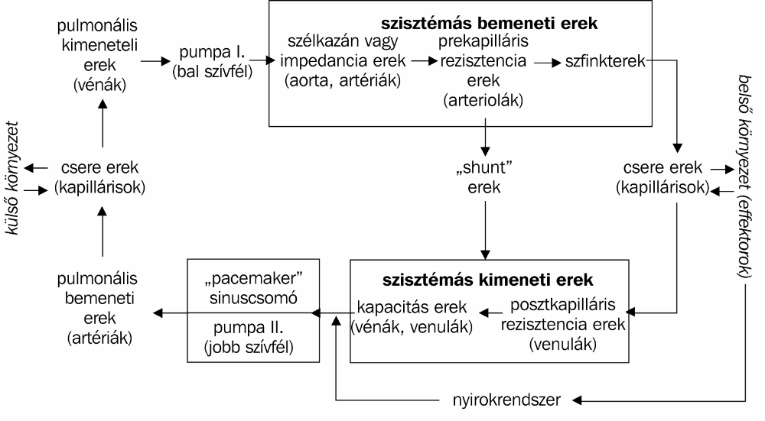
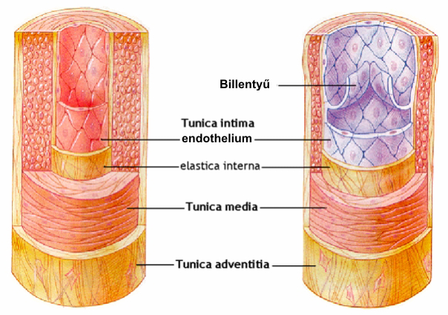

Vörösvértestek áramlása: (A) nagy artériák - rendezetlen áramlás (B) kis artériák - axiális áramlás (C) kapillárisok – bólusáramlás
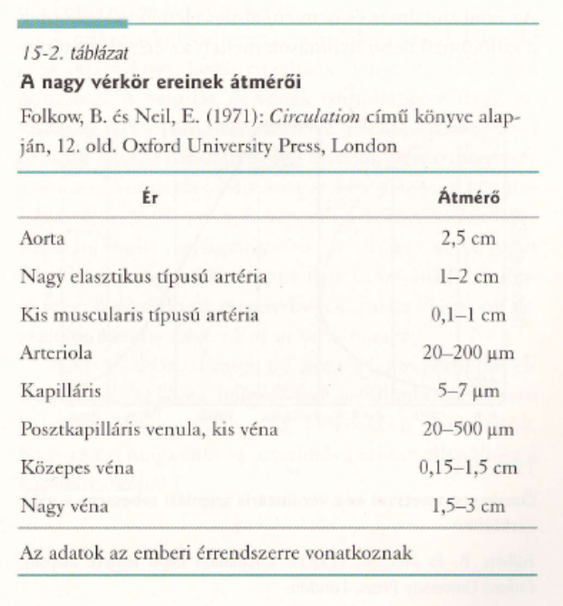

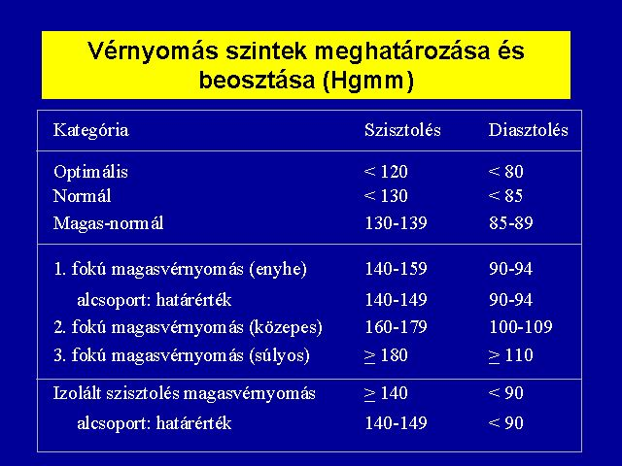

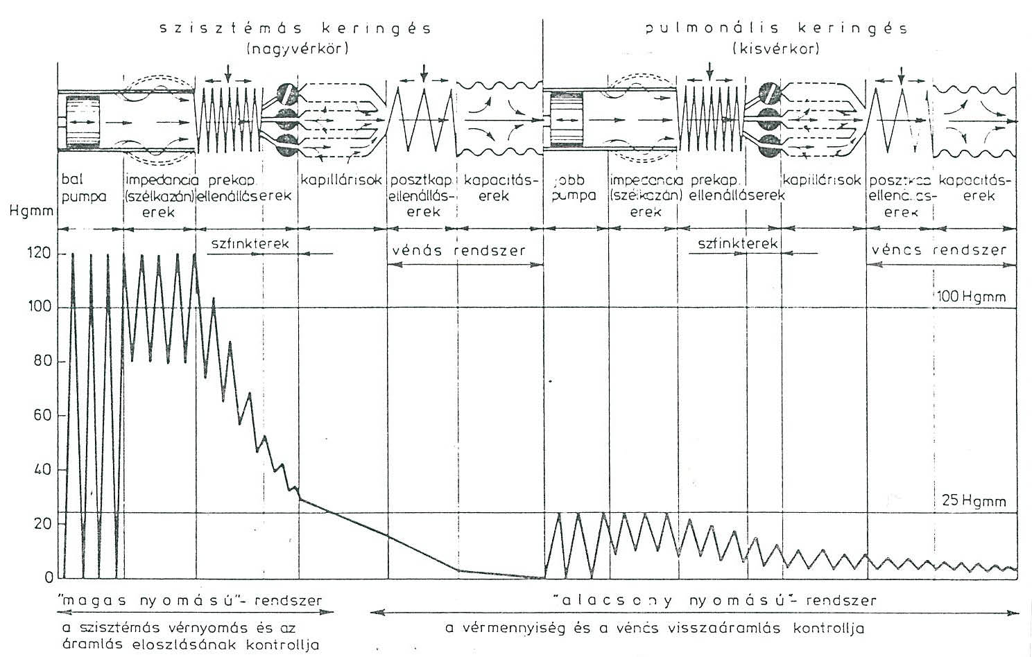

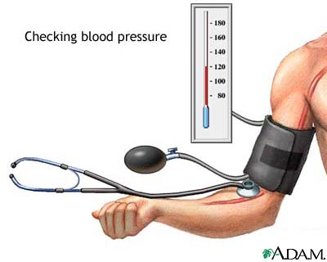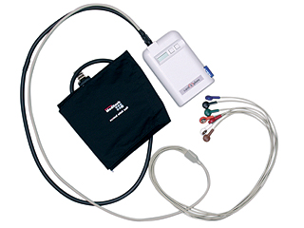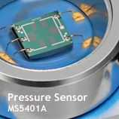
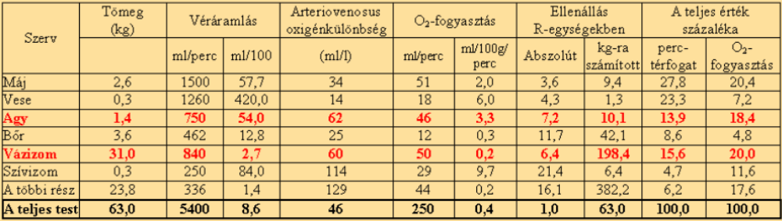
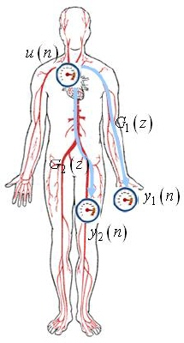
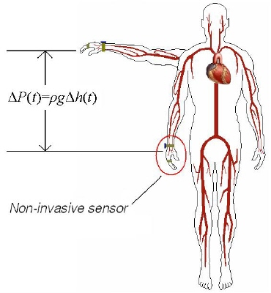

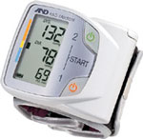

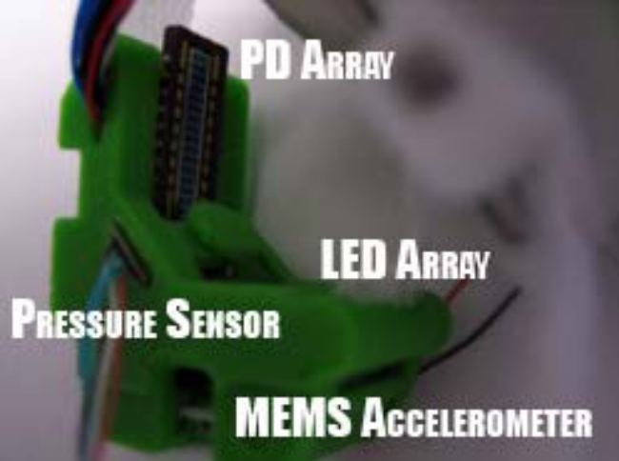
Ptm be the transmural pressure:

Ptm ≈ P_{MAP} −ρ ⋅ g ⋅ h − Pcuff ,with P_{MAP} as the mean arterial blood pressure,
ρ ⋅ g ⋅h as the hydrostatic pressure offset occurring when the pressure measurement site is not located at the same height as the heart, and
Pcuff as the cuff pressure applied to the outside of the blood vessel from an external pressure source.

The amplitude of the PPG signal is examined to find the zero transmural pressure point, where:

P_{MAP} = ρ ⋅ g ⋅ h − Pcuff

More specifically, the protocol utilized for our PPG calibration is as follows: The instrumented wearer’s hand is raised to a comfortable height above the heart; typically this is between 40 and 60 cm. After an initial rest period of two minutes, the arm height is decreased from the highest
position above to the heart to the lowest position below the heart in decrements of 10 cm. Data are collected at each arm position for a period of 20 seconds before offline postprocessing
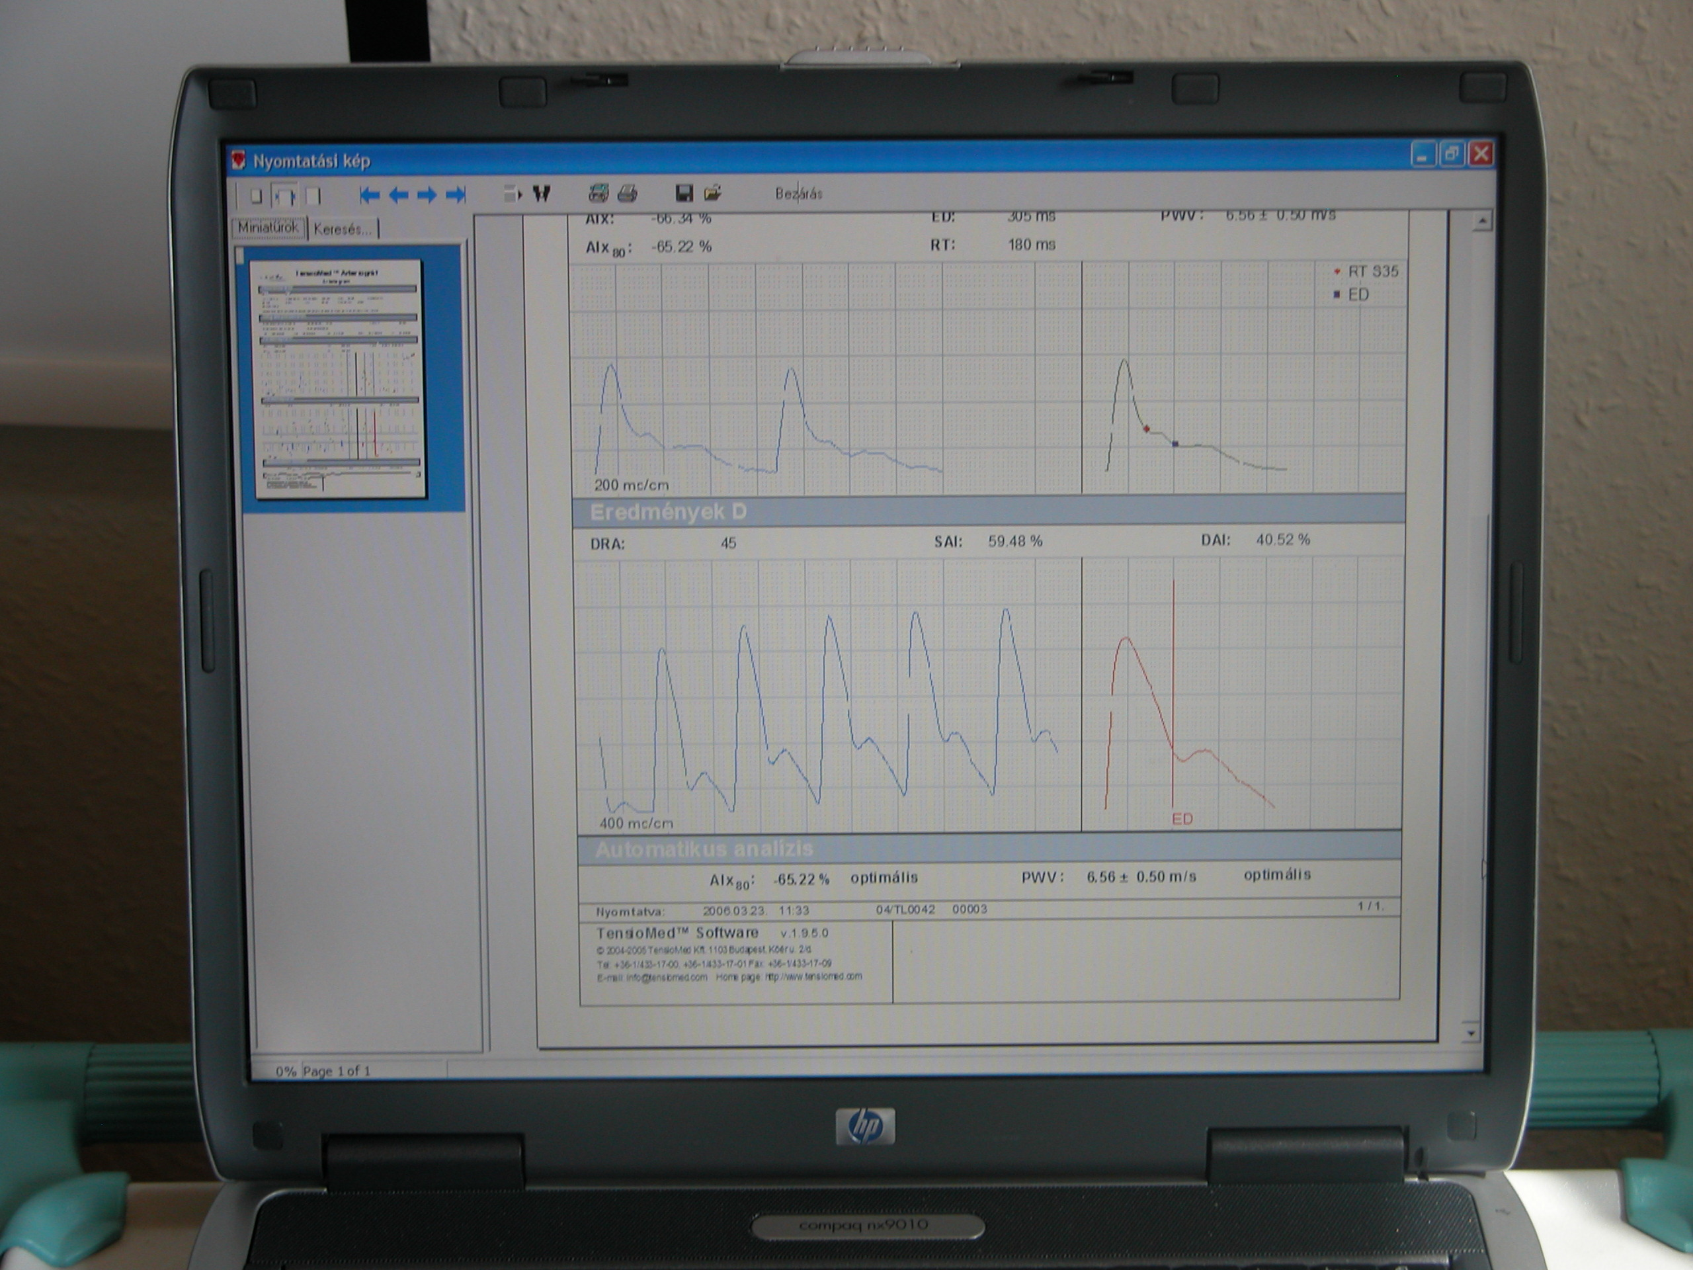Arteriográf

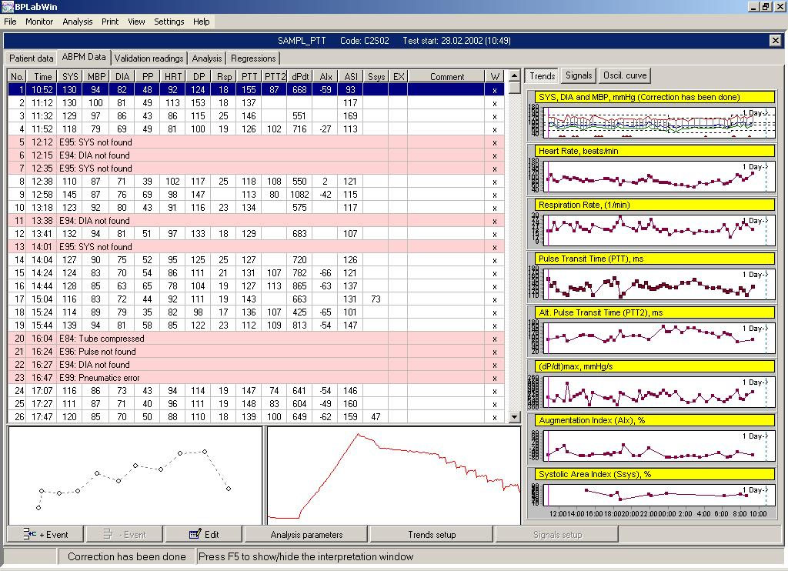

PPG
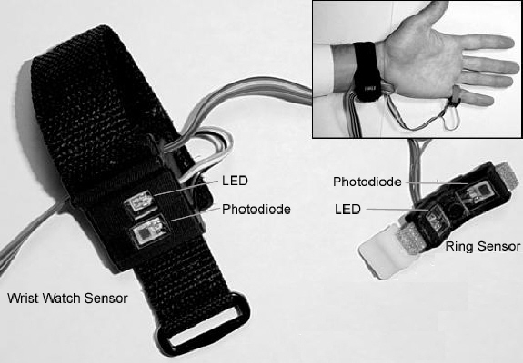
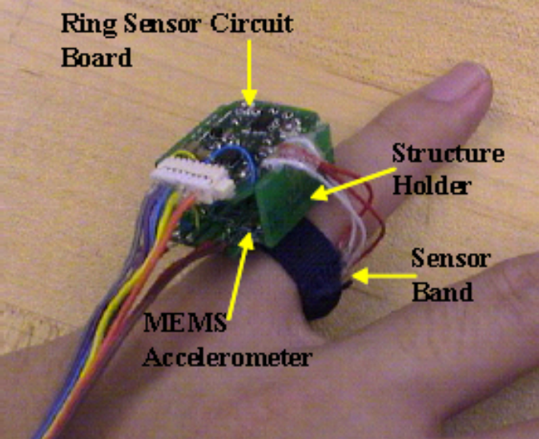PPG
http://darbelofflab.mit.edu/files/SPIE-Levi-Peter-2-05%20_Final%20Revision.pdf
MEMS accel collocated with PPG ring sensor

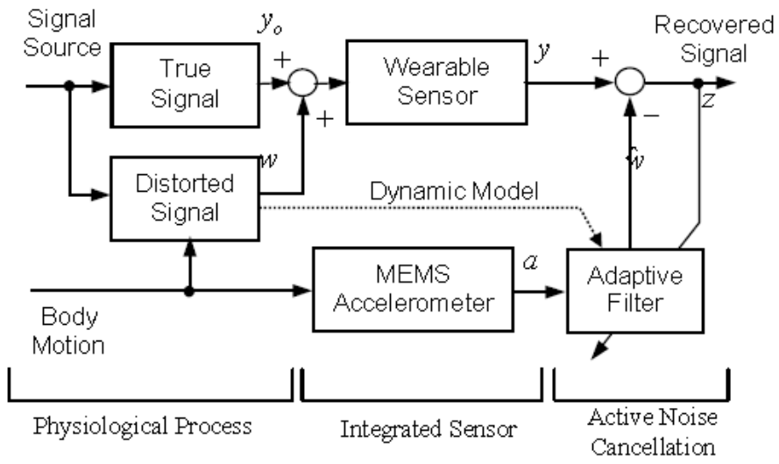
Block diagram of active noise cancellation of PPG. signal using MEMS accelerometer
Adaptive Noise Cancellation is a powerful tool for coping with the motion artifact problem. Figure 1 shows a motion-tolerant wearable sensor using adaptive noise cancellation. The sensor is a ring photoplethysmograph (PPG) sensor measuring pulse and oxygen level at the base of the finger. The PPG sensor is equipped with a MEMS accelerometer to measure the acceleration of the finger. Although the PPG sensor signal is corrupted with noise due to the finger motion, it can be recovered by using the finger acceleration signal as a noise reference and canceling out the interference caused by the motion.

PPG módszer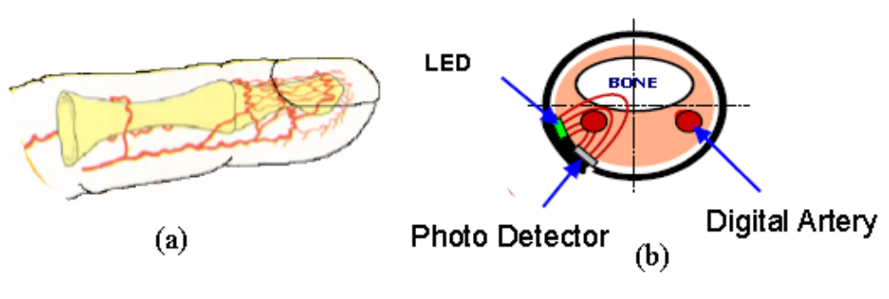
Anatomy of a digital artery (a) and finger base photoplethysmograph (b)

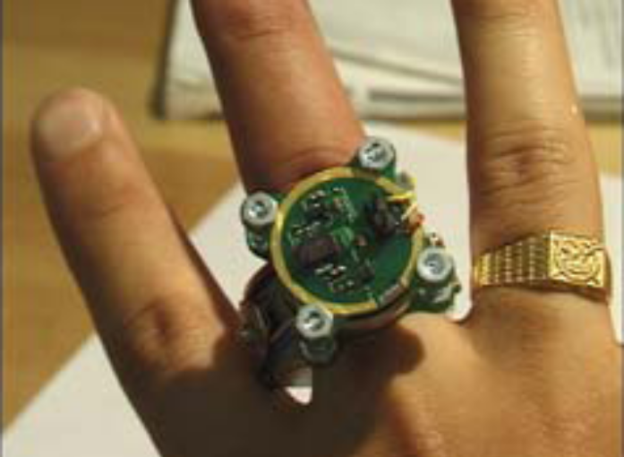

MIT Ring sensor
Photoplethysmograms (PPG) have become a powerful diagnostic tool for physicians over the last 20 years. In particular, they are capable of providing continuous information regarding a patient’s pulse rate, respiratory rate, and oxygen saturation. PPG sensors typically consist of two LEDs and a single photodetector (PD) oriented such that a vascularized region of tissue is encapsulated. Changes in measured light intensity at the photodetector primarily result from changes in the volume of blood in the optical path between the LEDs and PD. As more blood enters the optical
path, less light is recorded at the detector.

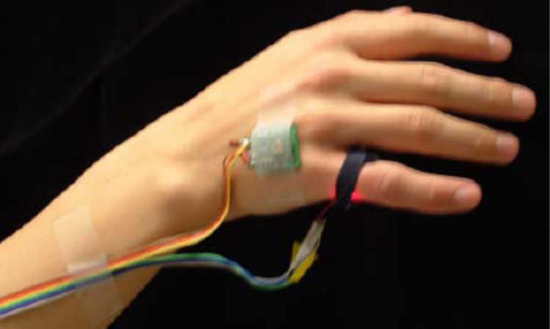
The key concept is to measure the patient’s motion with a multi-axis MEMS accelerometer incorporated into the sensor body, and use the acceleration information to correct the motion-corrupted signal. The distortion of the PPG signal may be estimated based on adaptive filtering technology.

Accelerometer and PPG sensor placement on hand and finger
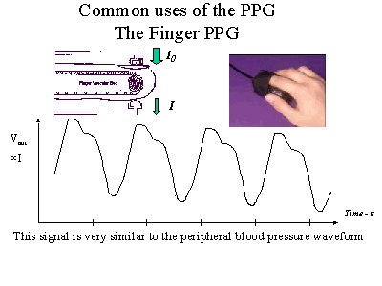

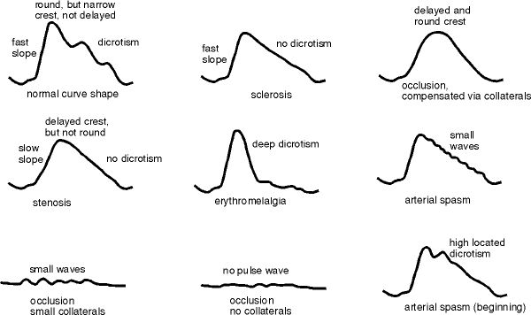

vérnyomásábra_szines.doc

